Week8_Resolving Merge Conflicts

(GitDemo)

Objective:
Implement conflict resolution when multiple users are updating the trunk (or master) in such a way that it results into a conflict with the branch’s modification.
Phase 1: Initial Git Configuration
Step 1: Verified Git Version
git version
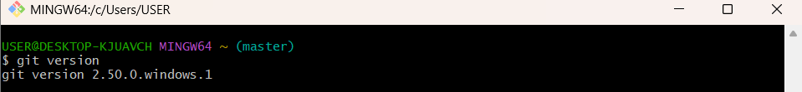
Step 2: Set Your User Name: This name will be associated with your commits.
git config --global user.name https://github.com/SaguturuShruthi
Step 3: Set Your User Name: This email will be linked to your commits.
git config --global user.email krishnashruthi2004@gmail.com
Step 4: Configured User Information
git config --global --list

Phase 2: Environment Setup: Integrating Notepad++
Step 5: Confirmed notepad++ Command Not Found Error
Step 6: Added Notepad++ to Environment Path
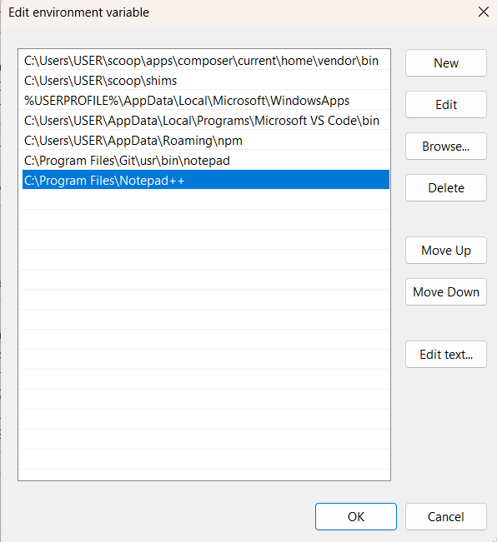
Step 7: Set Notepad++ as Git's Core Editor
git config --global core.editor "notepad++.exe -multiInst -nosession"

Step 8: Verify the Editor Configuration: To confirm the setup, run this command.
git config --global -e
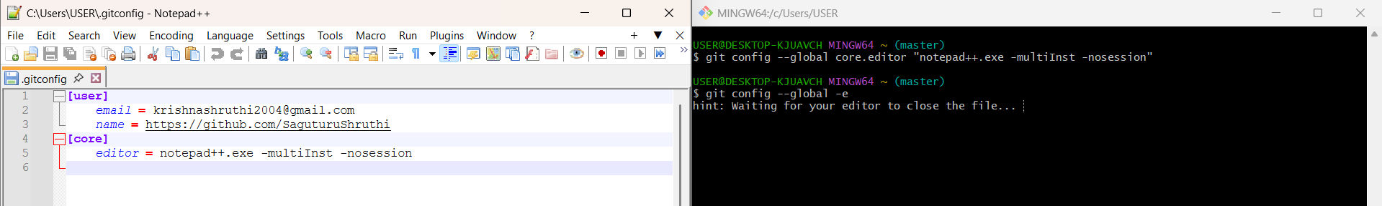

Phase 3: Branching & Merging
Step 9: Created and Switched to a New Branch:
git checkout -b GitNewBranch
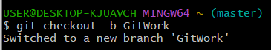
Step 10: Committed Work to the New Branch:
git add hello.xml
git commit -m "Add hello.xml to GitWork Branch"
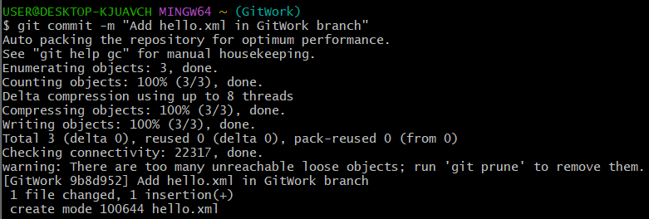
Step 11: Merged the Branch into Master:
git checkout master
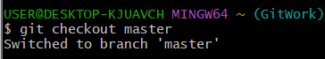
git merge GitNewBranch
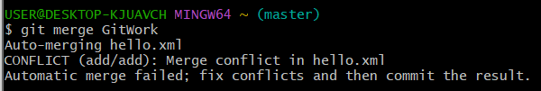

Phase 4: Merging
Step 12: Switched back to master: Used difftool to visually compare master and GitWork Branch.
git difftool master GitWork Branch
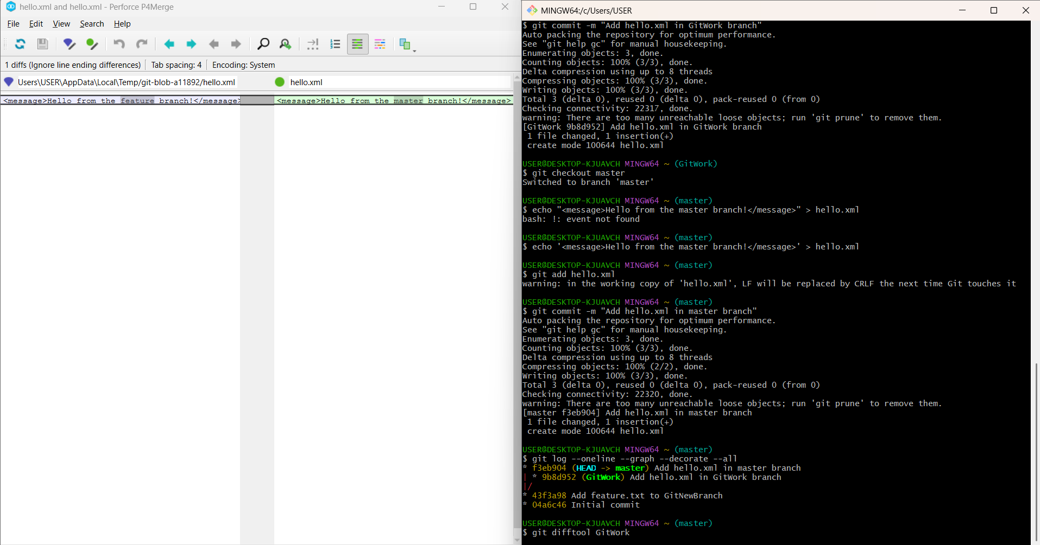

Step 13: Merged Branch into Master: Executed the merge command to bring changes from GitWork into master.
git merge GitWork

Step 14: Commit
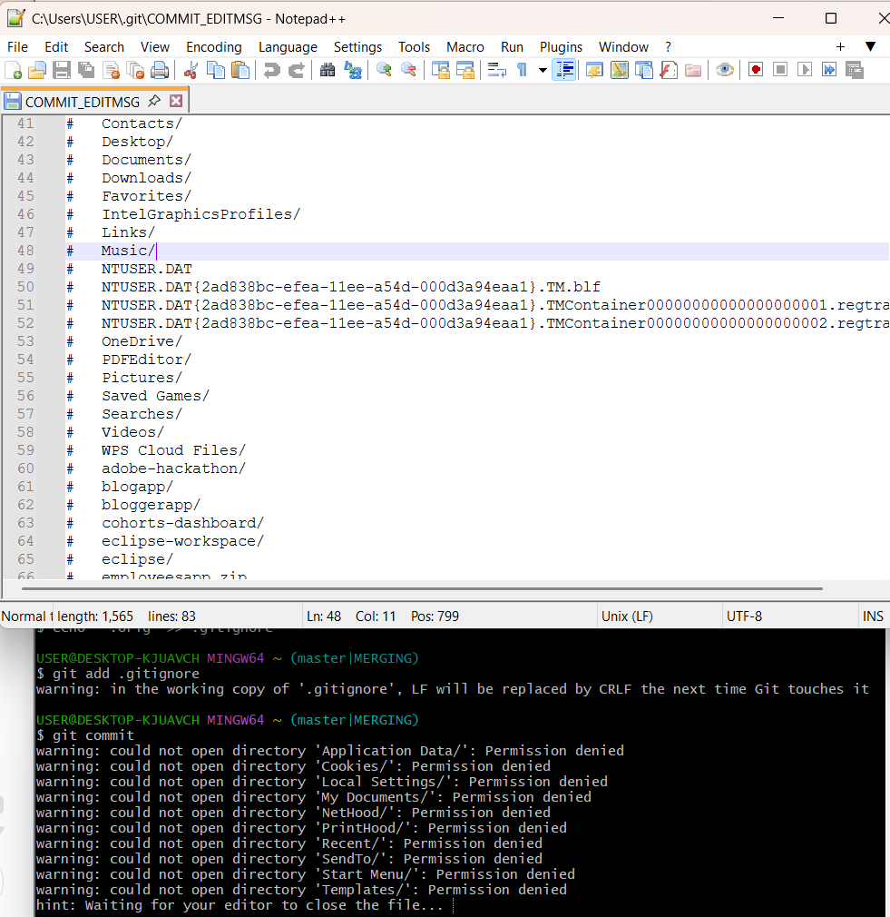
Step 15: Viewed the commit history with a graph, showing both branches pointing to the same commit post-merge.
git log --oneline --graph --decorate
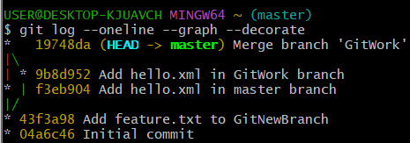
Step 16: Deleted Feature Branch: Deleted the now-merged GitWork.
git branch -d GitWork
